DL_6
Lesson 6 – Developing new products
Aim: To understand how new products are developed.
Task 1
Look at the scheme that reflects the general process of developing new products and read the text.
Looking at the scheme answer the following questions:
- Which occupation is important for each process?
- Which occupation is typical/important in the food industry? Why?
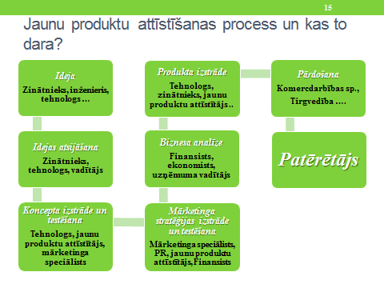
Process 1 – Generating ideas, based on three approaches:
- Internal resources – scientists, engineers, ordinary workers
- External resources – distributors, suppliers, competitors, clients
- Crowdsourcing – businesses welcome anyone to share their ideas

Process 2 – Developing ideas. The following questions are answered:
- To eliminate not valid ideas
- R-W-W (real, win, worth doing) principle:
- Is it real? – Is there a real need for this product in the market and will consumers buy it?
- Can we win? – Will this product be competitive enough in the long-term? Does the company enough resources to make this product a success?
- Is it worth doing? – Does the product match the company’s strategy? Will we earn enough with it?

Process 3 – Creating a concept and testing it
- The product concept is a detailed description of the idea that is expressed in the consumers’ language – Who will use the product? What benefits will it have? When will it be consumed?
- Testing of the product concept is carried out by a target group in order to understand whether this product will seem attractive to consumers

Process 4 – Development of a marketing strategy
- Development of a marketing strategy for a product based on the product concept focuses on 3 main aspects:
- Target market, valuable offer, planned market share, profit goal for the first year
- Price, points of sale and marketing budget for the first year
- Planned sales volumes in the long-term, profit goals, marketing mix

Process 5 – Business analysis
- Evaluating planned sales, expenditure and profit with the aim to understand whether these indicators match overall goals of the company (as an example an already commercialised product can be discussed)

Process 6 – Manufacturing of the product
- Manufacturing the real product or its first prototype in order to understand whether the product can be moved to the market
- Very often potential customers are invited to test the prototype

Process 7 – Test marketing The process then the product and its marketing programme are tested in the real conditions

Process 8 - Commercialization
- Introducing the product into the market – domestic and/or export.

Being in the market each product has its life cycle. The manufacturer is interested to make this cycle as long as possible. Taking into account the current stage of the cycle it is possible to predict and plan accordingly further manufacturing and sales, as well as adjust marketing strategy and tactic. This theory is based on the view that it is possible to distinguish certain stages of life cycle as with people – introduction, growth, maturity and decline. See Picture 1 Product life cycle.
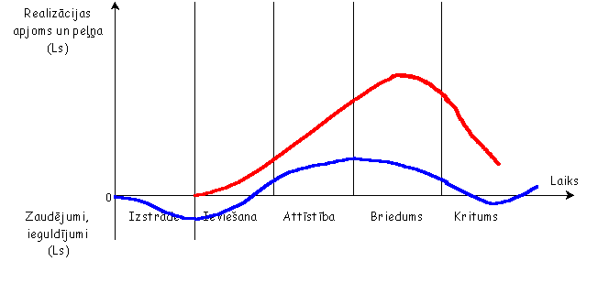
Picture 1 Product life cycle.

Stage 1 – Product introduction
- The stage begins with the introduction of the product into the market when the revenue is „0” and the profit is negative.
- The company has to invest a lot into the movement of the product (where to sell) and promotion (advertising).
- This is the end stage for many products. The following difficulties are faced::
- The company lacks resources and technical and marketing knowledge;
- Initial product price to cover the manufacturing expenses can be too high.
Marketing specialists should be alert as to weak points of the product; corrections should be introduced immediately. First marketing campaigns should target the easy to reach and responsive market segment.
Stage 2 – Product growth
- The stage of product growth is critical because competitors’ reaction and measures affect the product to a great extent
- Revenue and profit are growing

Main activities:
•To strengthen market share by highlighting the benefits of the product
•To analyse the product in relation to the competitors’ products and to introduce corrections
• Aggressive pricing policy, discounts, special offers, free testers
•To boost consumers’ loyalty to the brand
•To penetrate the market by approaching different market segments and diversifying the product to satisfy a greater variety of consumers’ need and wishes (product mix)
•To widen distribution channels, also geographically
•To monitor the timing and quality of delivery
Stage 3 – Product maturity
- The stage is characterized by strong competition; competitors highlight their versions of the product and improvements
- Revenue reaches the maximum. The profit is falling
Actions:
•Advertising and work with distributors
•New versions of the product that match consumers’ wishes and need more precisely
•New ways of application of the product
•The increase of consumption among the current customers (large packaging)
•The growth of the number of customers (conquering global markets, niche markets)
•Packaging variety (for travellers, for a single use)
•Improving product quality
•Introducing changes in other aspects of marketing mix: promotion, price, distribution
Stage 4 – Product decline
- During this stage revenue is falling due to new and innovative products in the market
Possible actions:
•To stop sales if they are not profitable
•To reposition - a new strategy of positioning the product to ensure a longer product life
•Work with dealers, distributors that can prolong the product life
•Addressing other products that are at earlier product life stages
Task 2
In your group come up with your own INNOVATIVE product to be manufactured and introduced in the market. Explain why this product is unique in the market; what makes it different from analogous products.
What is the product?
Which sub branch of the food industry does it represent?
What is the target group – children, teens, senior citizens etc.? Why?
How different is it from analogous products?
What packaging will it have?
Where will it be sold, why? How will it be advertised etc.?

