SP_3
Lesson 3 – Characteristics of the employees in the industry
Aim: To understand competences and skills of employees, as well as the criteria for recruitment.
Guidelines:
- During the lesson students learn about competences and skills of employees, as well as the criteria for recruitment.
- During the lesson students use the worksheet.
- Students are divided into groups. Each group reads its part of the text. Each students fills in the column „WHAT I KNOW”.
- Each group retells the information and others fill in the column „WHAT I HAVE LEARNT”
Task 1
Question | WHAT I KNOW | WHAT I HAVE LEARNT
- Which gender is most represented in the food industry?
- What about age groups?
- How are employees’ skills and competences evaluated? Are there any differences?
- During the recruitment process what is being evaluated? Are there any differences?

Students read the text and fill in the column WHAT I HAVE LEARNT in Task 1
Employees’ characteristics according to age and gender
Female employees slightly outnumber male employees in the food manufacturing businesses. (Picture 15) In the age groups 25-60 years old the genders are equally represented – about 28% each. (Picture 14)
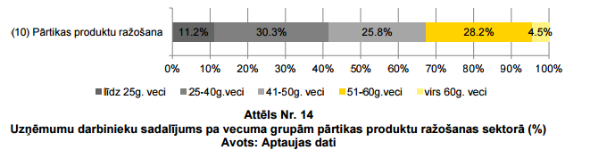

Female employees in the age group 41-50 years old represent 65.5%. A large proportion of female employees is in age groups 25-40 years old and younger than 25. In the age group older than 60 years old the percentage of female employees is smaller (41.3%). This can be observed across the whole country, which can be explained by the fact that women leave labour marker earlier than men.
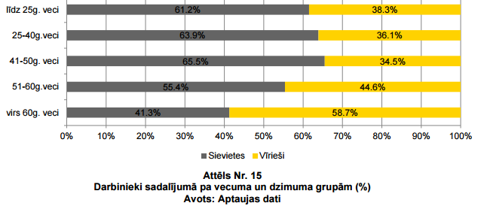

Employees’ competences and skills

When evaluating knowledge and skills of newcomers to the industry (after graduating vocational schools), the most valued is their ability to become a team player (64.3% of respondents marked this criterion with „4” or „5”), as well as their attitude to work duties and determination (63.2% of respondents marked this criterion with „4” or „5”)
The least valued is the knowledge gained during the study process (only 40.2% of respondents marked this criterion with „4” or „5”, which might indicate problems in the education system. The same can be referred to people with work experience. Willingness to improve one’s skills is valued a bit less important than other criteria. Professional skills of newcomers are the second least valued criterion, whereas with the experienced employees this criterion is the most valued one. This can indicate steady improvement of professional skills with time. The low level of professional skills can be explained by the lack of practical involvement during the study process, which is confirmed by reports from industry businesses.
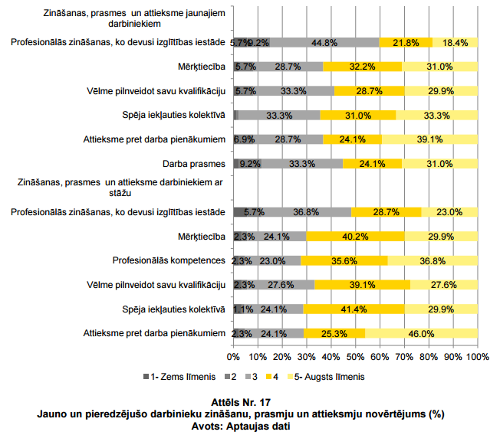

It can be seen in Picture 17 that newcomers are highly motivated to work, get first experience, are communicable and show initiative in the new environment, whereas experienced employees are more competent, determined because they can appreciate the desired result. The evaluation of the knowledge obtained during the study process leads to the necessary overhaul of the efficiency of the education system as work experience makes up for this drawback..
Employees’ recruitment criteria

When recruiting employees for basic jobs in the food industry employers value professional skills the most (82.2% of respondents marked it as highly important). 58.3% of respondents considered the knowledge of foreign languages as not important for basic jobs. Only 18% of respondents consider this criterion important or highly important

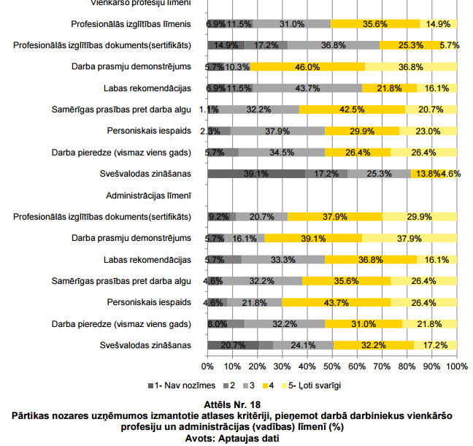
When recruiting employees for administrative jobs in the food industry employers value professional skills the most (77% of respondents marked it as important or highly important), along with personality and education (67.8% and 70.1% of respondents considered them important). All other criteria are equally important.
Professional skills are the most important criterion when recruiting a new employee. It is more important for basic jobs if compared to administrative jobs. Education and language skills are least important according to employers. For basic jobs knowledge gained during the study process is of less importance. This can be explained by the fact the practical experience that can be gained in the workplace. If we look at the administrative level, then it can be concluded that other criteria (except professional skills) are more important if compared with basic jobs. Education is more important as well.

