DL_2

Lesson 2 - What and how much the food industry produces. Food industry export
Aim: To understand what the food industry produces, retail and TOP businesses
Task 1
Write your answers WHAT I KNOW to the questions.
Question | WHAT I KNOW | WHAT I HAVE LEARNT
- What is food industry?
- What sub-branches does food industry consist of? Name them.
- Where are the food products produced in Latvia sold?
- How many food businesses are there in Latvia?
- Which products were produced the most in 2012?
- Where do we export?
- Name the largest food businesses, which sub-branch they represent.

Task 2
Read the text and fill in the column WHAT I HAVE LEARNT in Task 1.
The food industry
The food industry mainly focuses on the domestic market, so during the economic crisis, with the decreasing domestic demand, the turnover of the industry decreased. However, the latest trends show that there has been a shift in the focus on export, which has allowed the industry to start recovering. In 2013 the volume of produced goods was 6% larger than in 2012. With the export potential and the improvements in the domestic market, the beginning of 2014 was marked with the growing volume of production – January-April figures are 6% larger than one year ago.
In 2012 the food and beverage industry was represented by 840 businesses, which is 10% of all businesses involved in manufacturing industry. They employed more than 25 500 people, which is 22% of all the employees in manufacturing industry.
In the EU food industry is the largest manufacturing industry as to its turnover (EUR 954 billion), which makes 12.9% of the total turnover. Moreover, food industry is the largest employer in the EU with 4.2 mil employees, or 13.5%.

Manufacturing, or what and how much do we produce?
In 2012 the largest sub-branches of food industry were manufacture of meat and meat products, and manufacture of dairy products, 20% each. Manufacture of beverages, fish, crustaceans, and bread and pastry products (Picture 1) was also important. The distribution has shifted only a little in the last years with the decrease in beverages and increase in fish products.
1. attēls. Pārtikas un dzērienu nozares 2012. gada izlaides sadalījums pa pārtikas veidiem, %

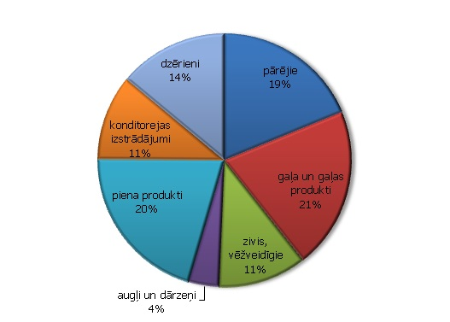

End markets, or where is the produce sold?
When we speak about the end markets of food industry, it should be mentioned that the larger part of the produce is sold in the domestic market with only 34% being exported. That is the reason why the development of the domestic market is so important for the producers.
The data on food products turnover indicate a certain post-crisis stagnation in the realization of the produce in the domestic market Picture 2), and the increase of the turnover has been very slow for the last two years. The economic situation in Latvia is improving and so is the income, which in its turn is positively adding to the buying ability. There is a great hope that the demand for food products will rise steadily. At the same time it is important to consider not only the income of people but also the number of buyers. The latter is falling due to the demographic situation and as the result of emigration. The UN predicts that in 2050 the number of inhabitants in Latvia will be 20% less than now.
2. attēls. Pārtikas apgrozījuma indeksi nozarēs pēc produkcijas realizācijas virziena, 2010=100, s.i.
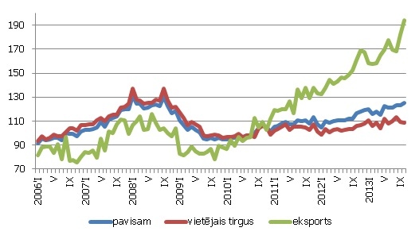
On the other hand, the good news is the growth of the turnover in the export markets and is far beyond the pre-crisis level. Based on the macroeconomic data it can be concluded that businesses have shifted their focus on export as a measure to solve the decrease in the domestic demand. In 2012 the major part of exported goods went to Lithuania (31%), Estonia (21%) and Russia (11%). When we look at the export of beverages, then the largest export partner was Russia (72%) followed by Lithuania (7%) and Estonia (5%). [3].
In 2013 the turnover of the industry is in the rise, it has increased by 8.9%, with the export growth by 16 % and the turnover in the domestic market – by 5.3%.
3. attēls. Produkcijas eksports pa valstu grupām, 2013.gadā.

TOP 3 food and beverage producers in 2012 as to their turnover

The largest food and beverage producers as to their main activities (10 and 11)
- Dobeles Dzirnavnieks AS
- Latvijas Balzams AS
- Rīgas Piena kombināts AS

Processing and preserving of meat and production of meat products
- Kurzemes Gaļsaimnieks SIA
- Ķekava putnu fabrika AS
- Rēzeknes Gaļas kombināts SIA

Processing and preserving of fish, crustaceans and molluscs
- Gamma-A SIA
- Karavela SIA
- Brīvais Vilnis AS

Manufacture of dairy products
- Preiļu siers AS
- Rīgas Piena kombināts AS
- Tukuma piens AS

Manufacture of bakery and farinaceous products
- Adugs SIA
- Fazer Latvija SIA
- Hanzas Maiznīca AS

Manufacture of other food products
- Baltur-R SIA
- NP Foods SIA
- Spilva SIA

Manufacture of beverages
- Cēsu alus AS
- Cido grupa SIA
- Latvijas Balzams AS

Manufacture of beer
- Aldaris AS
- Bauskas alus SIA
- Cēsu alus AS

