DL_1

Lesson 1 – A Short Introduction to Food Industry
Aim: To understand the concept of food product, food industry and its structure
Task1
Write your answers to the questions in the column WHAT I KNOW
Question | WHAT I KNOW | WHAT I HAVE LEARNT
- What is a food product?
- What is food industry?
- Is there any difference between food industry and agriculture? If yes, then what?
- What is the classification of national economy sectors in Latvia and EU? Name the system.
- Which manufacturing industry is the largest in Latvia? What parameters can be used to describe it? How would you characterise each of them?
- What sub-branches does food industry consist of? Name them.

Task 2
Read the text and based on what you have read write your answers in the column WHAT I HAVE LEARNT.

A Short Introduction to Food Industry

A food product is any product that is meant for human consumption.

A processed food product is a product that has been exposed to certain technological processes to change its qualities or use (to be used in cooking meals or for immediate consumption).
Food and beverage industry (1) (further - food industry) is one of the most important and dynamic branches of industry. It is part of people’s everyday life. Food industry is vitally important for each country, and it is the largest branch of manufacturing industry in Latvia, that represents 25.2% (Year 2013) of the added value of manufacturing industry.
Table 1. Structure of manufacturing industry in 2013, %
 | Output | Employees
Manufacturing industry - | 100 | 100
Food and beverage industry | 25,2 | 22,2
Light industry | 4,3 | 11,0
Forestry | 23,1 | 19,9
Paper manufacturing and publishing | 4,5 | 4,0
Chemical industry and related industries | 7,5 | 6,5
Non-metal mineral articles manufacturing | 6,5 | 4,2
Metal and metal articles manufacturing | 10,7 | 10,0
Electric and optical equipment manufacturing | 6,2 | 3,9
Machinery and equipment manufacturing | 2,4 | 2,9
Automotive industry | 4,0 | 3,3
Other branches of manufacturing industry | 5,7 | 12,1
* Report on the Economic Development of Latvia June 2014 by the Ministry of Economics of the Republic of Latvia (latest reports can be found on www.em.gov.lv)

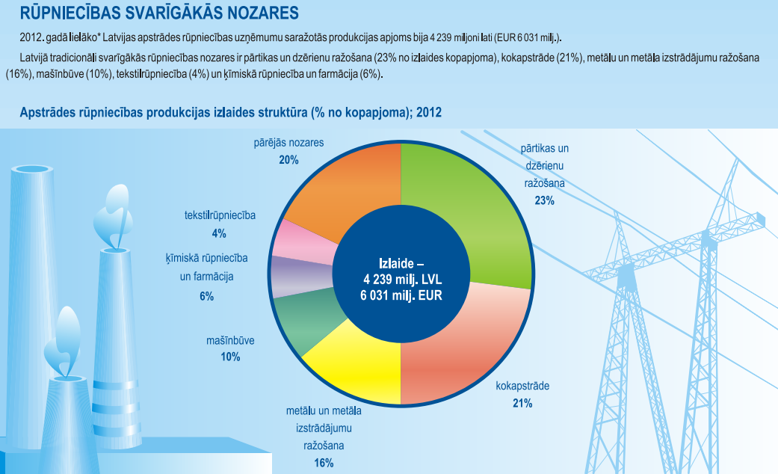
According to NACE Rev.2 food industry falls under manufacturing industry (Section C)
The two components of food industry are manufacturing of food products (NACE Rev.2 Division 10) and manufacturing of beverages (NACE Rev.2 Division 11).
Manufacturing of food products comprises nine groups:
- Processing and preserving of meat and production of meat products;
- Processing and preserving of fish, crustaceans and molluscs;
- Processing and preserving of fruit and vegetables;
- Manufacture of vegetable and animal oils and fats;
- Manufacture of dairy products;
- Manufacture of grain mill products, starches and starch products;
- Manufacture of bakery and farinaceous products;
- Manufacture of other food products;
- Manufacture of prepared animal feeds.
Whereas manufacturing of beverages comprises seven groups:
- Distilling, rectifying and blending of spirits;
- Manufacture of wine from grape;
- Manufacture of cider and other fruit wines;
- Manufacture of other non-distilled fermented beverages;
- Manufacture of beer;
- Manufacture of malt;
- Manufacture of soft drinks; production of mineral waters and other bottled waters.

[1] – Food industry – processing of crops, meat and fish products into food products to be consumed by humans or animals, as well as production of other goods that are not directly used as food. By food industry we do not mean agriculture that supposes plant cultivation, livestock breeding, forestry and extraction of other primary products from their natural habitat or places of breeding and cultivation.
[2] - NACE Rev.2 2.red. – to ensure comparability of statistics by different EU countries Statistical Classification of Economic Activities in the European Community (NACE) is used, which presents the classification of sectors of national economy and institutional bodies. NACE includes four levels and one intermediate level:
- Level 1 - Sections are represented by a code composed of one alphabetic letter;
- Level 1+ - Subsections are represented by a code composed of two alphabetic letters;
- Level 2 – Divisions are represented by a code composed of two digits;
- Level 3 – Groups are represented by a code composed of three digits;
- Level 4 – Classes are represented by a code composed of four digits
About NACE in short
Statistical classification of economic activities in the European Community (NACE) is a set of main principles that regulate production and availability of statistics in economic activities.
NACE and the integrated system of classifications of economic activities and products
1. NACE is the acronym (from “Nomenclature générale des Activités économiques dans les Communautés Européennes" (Statistical classification of economic activities in the European Community that is used to designate the various statistical classifications of economic activities developed since 1970 in the European Union. NACE provides the framework for collecting and presenting a large range of statistical data according to economic activity in the fields of economic statistics (e.g. production, employment, national accounts) and in other statistical domains.
2. Statistics produced on the basis of NACE are comparable at European and, in general, at world level. The use of NACE is mandatory within the European Statistical System
The international system of economic classifications
3. The comparability at world level of statistics produced on the basis of NACE is due to the fact that NACE is part of an integrated system of statistical classifications, developed mainly under the auspices of the United Nations Statistical Division.

Saimnieciskās
darbības Produkti Preces
SITC
HS
CPC
ISIC
Pasaules
līmenis

KN
PRODCOM
CPA
NACE
ES līmenis

valsts NACE
valsts PRODCOM
valsts CPA
Valsts
līmenis

ir atsauces klasifikācija. Klasifikācijas savstarpēji ir strukturāli saistītas

ir atsauces klasifikācija. Klasifikācijas saistītas ar kodu atbilstības tabulām

Klasifikācijas saistītas ar kodu atbilstības tabulām

Where:
- ISIC is the United Nations’ International Standard Industrial Classification of all Economic Activities.
- CPC is the United Nations’ Central Product Classification.
- HS is the Harmonized Commodity Description and Coding System, managed by the World Customs Organisation.
- CPA is the European Classification of Products by Activity.
- Prodcom is the classification of goods used for statistics on industrial production in the EU.
- CN stands for the Combined Nomenclature, a European classification of goods used for foreign trade statistics.
www.csb.gov.lv

